Statistics 2013/13
Played | 41
Won | 33
Drawn | 6
Lost | 2
For | 102
Against | 18
Honours (chronological order) | 2012-2013
- ESFA Danone Nations Cup 7-a-side City of Gloucester | Winners
- Rob Cruse Memorial Cup | Winners
- GPSFA 5-a-side | Winners
- ESFA Danone Nations Cup 7-a-side County | Winners
- ESFA Danone Nations Cup 7-a-side South West Region  - Npower League Cup | Winners  Finalists
- ESFA Danone Nations Cup 7-a-side National Finals | Runners Up
- GPSFA Large Schools Cup | Winners

Players
- Jamie Street –Goalkeeper | - Ben Gibson -Striker
- Marc Barnett –Left defence | - Matthew Baldwin –Midfield, defence
3. Luke Richards –Right defence | - Theo Margaritis -Midfield
- Myles Sohna –Centre midfield, captain | - Kyle Gibbs –Right midfield
- Harrison Sohna –Left midfield

“The signed shirt on display was the kit used in the ESFA Danone Nations Cup 7-a-side National Finals. This is the furthest Elmbridge has ever come in a footballing competition. We won the City, County and South West regional tournaments. Following this, we won every group game and the semi-final at the Nationals.
In the final, we did not lose in open play –only on penalties after extra time. I hope the shirt and the story serves as an inspiration to footballers at the school. It is a precious memento of an amazingly successful year.”
Mr Feltham, Elmbridge football

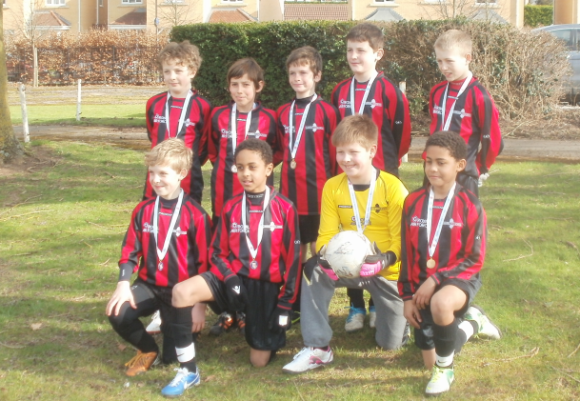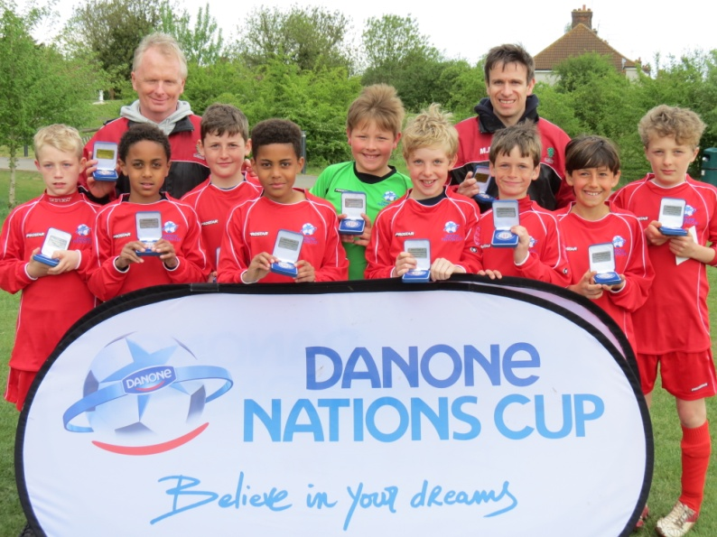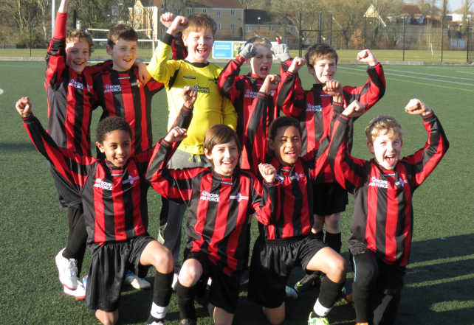
South West Regional Winners ESFA Danone Nations Cup City and County Winners
^{National Runners Up}
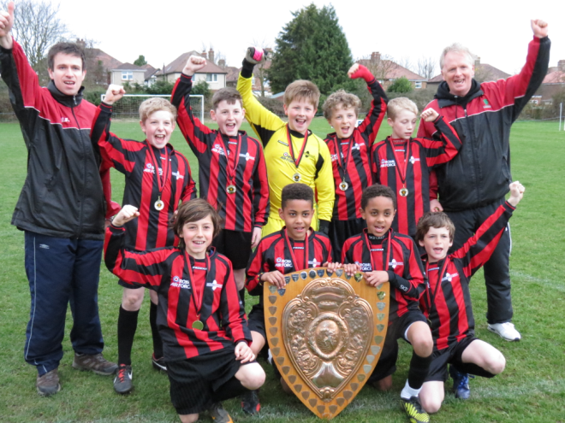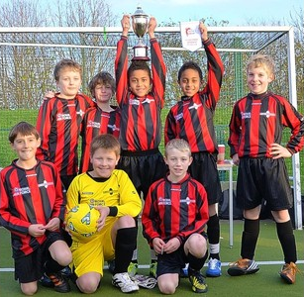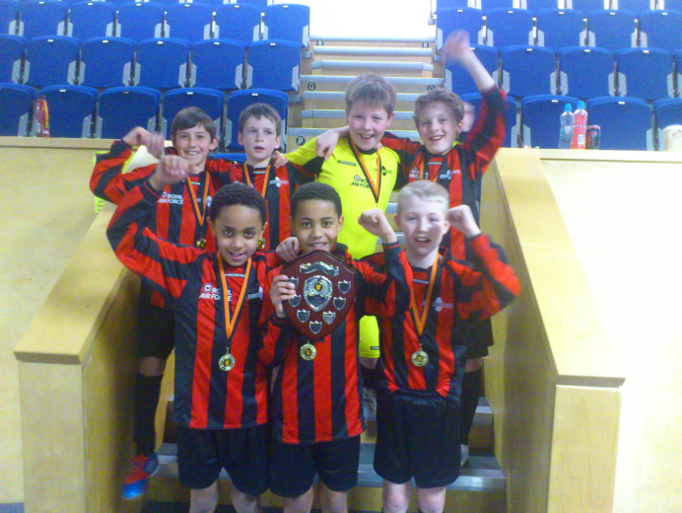
Large School’s Cup Winners Rob Cruse Memorial Cup Winners 5-a-side Winners

