

Year 6 Team 2026/27

Class Teachers:
Mrs Bourne-Clague    Year 6 Lead | Mrs Wiggins  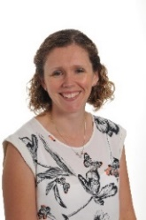 |  | Miss Hawkins   | Mrs Fagence  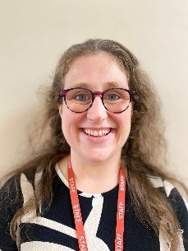 |  | Miss Maslen  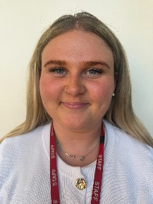
Teaching Assistants:
Mrs Morris  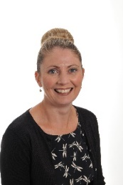 |  | 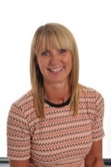  Mrs Crouch |  |  | 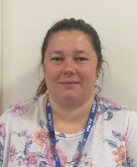  Mrs Kerr

Mrs Kerr, Mrs Howard, Mrs Morris and Mrs Hieron will teach across Year 6 on a Tuesday afternoon whilst Year 6 teachers meet for their Planning, Preparation and Assessment time.

