

Year 5 Team 2026/27

Class Teachers:
Mr Evans  Year 5 Lead  | Mrs Bradford   |  | Miss Maslen  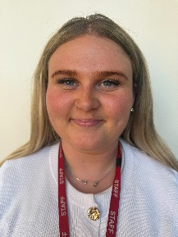 |  | Mr Hounsell  
Teaching Assistants:
Mrs Mansuri  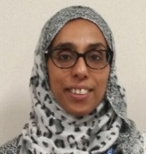 |  | Mrs Faulks   |  | Mrs Grainger  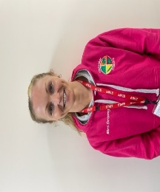

Mrs Morris, Mrs Howard, Miss Maslen and Mrs Bradford will teach across Year 5 on a Wednesday afternoon whilst Year 5 teachers meet for their Planning, Preparation and Assessment time.

