

YEAR 4 Team 2026/27

Class Teachers:
Mrs Radford  Year 4 Lead | Mrs Hook   |  |  | Mrs Cox 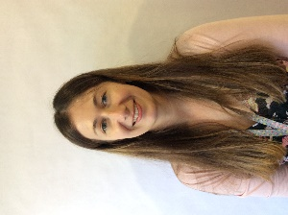 |  |   Miss Bell
PPA Teachers
Mrs Hieron   |  |  | Mrs Toppin  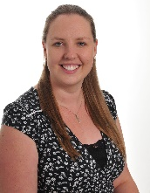
Teaching Assistants:
Mrs Womersley  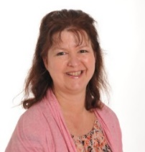 |  | Mrs Fyfe   |  |  | Mr Turner  

Mrs Hieron, Mrs Hook, Mrs Cox and Mrs Toppin will teach across Year 4 on a Wednesday afternoon whilst Year 4 teachers meet for their Planning, Preparation and Assessment time.

