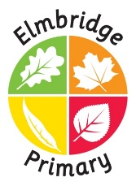

YEAR 3 Team 2026/27

Class Teachers:
Mr Jones    Year 3 Lead | Mrs Barthorpe  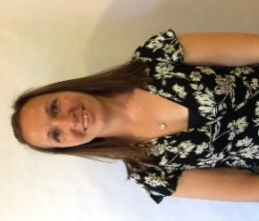 | Miss Marsh  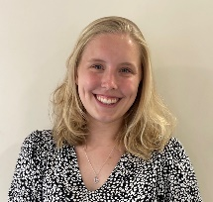 | 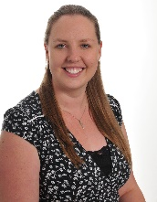  Mrs Toppin
Teaching Assistants:
  Mrs Holl | Mrs Hardman  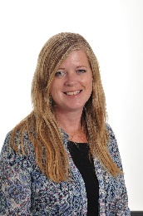 | 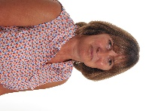  Mrs Coughlan | Miss Taylor  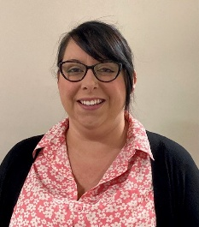

Mrs Williams, Mrs Toppin and Mrs Hieron will teach across Year 3 on a Thursday afternoon whilst Year 3 teachers meet for their Planning, Preparation and Assessment time.

